import java.sql.*;

public class Testing1 {

public static void main(String[] args) {

try{
Class.forName("com.mysql.cj.jdbc.Driver"); //Register

Connection con=DriverManager.getConnection(
"jdbc:mysql://localhost:3306/test","root","root");

Statement stmt=con.createStatement();

ResultSet rs=stmt.executeQuery("select * from student");
// -----------up to this line it contain's one table struc output
while(rs.next()){
System.out.println(rs.getInt(1)+" "+
rs.getString(2)+" "+rs.getInt(3));
}
con.close();
}
catch(Exception e){
System.out.println("Sorry for the inconvinence happened..! "
+ "Check the inputs properly one more time");
}
}

}

show databases;
create database test;
use test;
create table student(sid int unique not null, sname varchar(30) not null,smarks int not null);
desc student;
insert into student values(105,'Arthi',92);
select * from student;

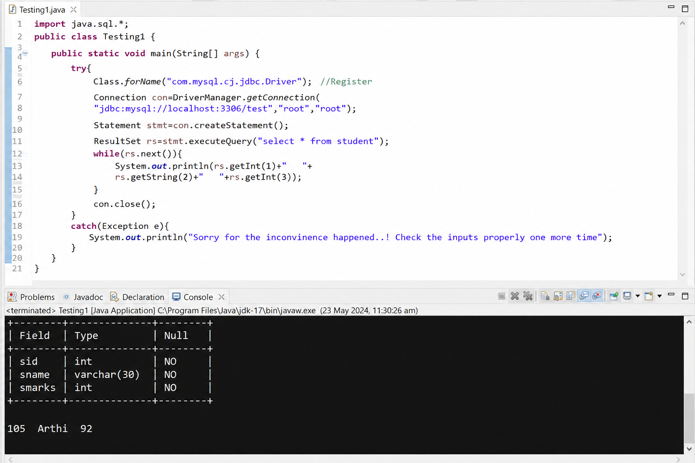

package CRUD;

import java.sql.Connection;
import java.sql.PreparedStatement;
import java.sql.ResultSet;

public class CRUD_Test {

public static void main(String[] args) {

CRUD_Test objTest = new CRUD_Test();

// INSERT
objTest.create_data("1", "Jinu", "jinu@gmail.com");
objTest.create_data("2", "Jawad", "jawad@gmail.com");

// READ
System.out.println("\n----- RECORDS -----");
objTest.read_data();

// UPDATE
objTest.update_data("2", "22", "Jawad2", "jawad2@gmail.com");

System.out.println("\n----- AFTER UPDATE -----");
objTest.read_data();

// DELETE
objTest.delete_data("1");

System.out.println("\n----- AFTER DELETE -----");
objTest.read_data();
}

// CREATE
public void create_data(String sl_no, String name, String email) {

DB_Connection db = new DB_Connection();
Connection connection = db.get_connection();

try {
String query =
"INSERT INTO user(sl_no,name,email) VALUES(?,?,?)";

PreparedStatement ps =
connection.prepareStatement(query);

ps.setString(1, sl_no);
ps.setString(2, name);
ps.setString(3, email);

int rows = ps.executeUpdate();

if (rows > 0) {
System.out.println("Record Inserted Successfully");
}

ps.close();
connection.close();

} catch (Exception e) {
e.printStackTrace();
}
}

// READ
public void read_data() {

DB_Connection db = new DB_Connection();
Connection connection = db.get_connection();

try {

String query = "SELECT * FROM user";

PreparedStatement ps =
connection.prepareStatement(query);

ResultSet rs = ps.executeQuery();

while (rs.next()) {

System.out.println(
rs.getString("sl_no") + " | " +
rs.getString("name") + " | " +
rs.getString("email")
);
}

rs.close();
ps.close();
connection.close();

} catch (Exception e) {
e.printStackTrace();
}
}

// UPDATE
public void update_data(String sl_no,
String new_sl_no,
String name,
String email) {

DB_Connection db = new DB_Connection();
Connection connection = db.get_connection();

try {

String query =
"UPDATE user SET sl_no=?, name=?, email=? WHERE sl_no=?";

PreparedStatement ps =
connection.prepareStatement(query);

ps.setString(1, new_sl_no);
ps.setString(2, name);
ps.setString(3, email);
ps.setString(4, sl_no);

int rows = ps.executeUpdate();

if (rows > 0) {
System.out.println("Record Updated Successfully");
}

ps.close();
connection.close();

} catch (Exception e) {
e.printStackTrace();
}
}

// DELETE
public void delete_data(String sl_no) {

DB_Connection db = new DB_Connection();
Connection connection = db.get_connection();

try {

String query =
"DELETE FROM user WHERE sl_no=?";

PreparedStatement ps =
connection.prepareStatement(query);

ps.setString(1, sl_no);

int rows = ps.executeUpdate();

if (rows > 0) {
System.out.println("Record Deleted Successfully");
}

ps.close();
connection.close();

} catch (Exception e) {
e.printStackTrace();
}
}



